
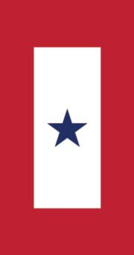

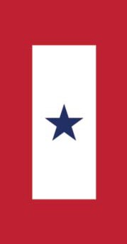
18th Annual Military Appreciation Golf Outing

Saturday, September 12th, 2026

Lunch and Registration at 12:00pm. Shotgun start 1:00pm.

Coyote Creek Golf Club
4935 Hillegas Road Fort Wayne, IN 46818 (260) 483-3148

$120 per Golfer
Includes: lunch,18-hole scramble, cart, beverages, snacks,
dinner & prizes.

Optional "FUN"

Silent Auction, Raffles, Skins, Mulligans, and MORE!
All proceeds will benefit local veterans and active military, at home and abroad.
Sponsored by: Fort Wayne Area Blue Star Mothers
of Indiana

We are mothers who now have, or have had, children honorably serving in the military. We are a non-profit (501[c]3) service organization supporting
local veterans and active duty military personnel.
Sponsorship Opportunities:
Many sponsorship opportunities are available, including golf cart sponsor, beverage cart sponsor, lunch and dinner sponsors, and hole sponsors.
Prize donations are also accepted. Call Sharon Eichman 260-446-6107or email golfoutingchair.in8@bluestarmothers.us with any questions.

- - - - - - - - - - - - - - - - - - - - - - - - - - - -
18th Annual Military Appreciation Golf Outing
Registration Form


seichm@Thank you for your support!
Captain’s Name: ________________________________________
Phone: ____________________________________________________
Email: ____________________________________________________
Player Name: ___________________________________________
Player Name: ___________________________________________
Player Name: ___________________________________________
Team fees ($480 per team): ______________
Mulligans ($20 per team): ______________
Skins ($20 per team): ______________
Total enclosed: ______________
(As a convenience, mulligans & skins can now be purchased for your team per the registration form or via the website.)
Registrations are accepted on a first-come basis only.
Your payment secures your reservation.
Deadline for Entry: September 1st, 2026 sign up and pay online:
fwbluestarmothers.org
or return this form and your check to: Fort Wayne Area Blue Star Mothers of Indiana
P.O. Box 11473
Fort Wayne, IN 46858-1473



