FORT WAYNE AREA BLUE STAR MOTHERS
QUILT RAFFLE
ALL PROCEEDS TO OUR MISSON OF PROVIDING SUPPORT TO
ALL VETERANS AND ACTIVE-DUTY MILITARY
TICKETS ARE $5 EACH OR 5 TICKETS FOR $20 - DRAWING Saturday AUGUST 8 – at Noon
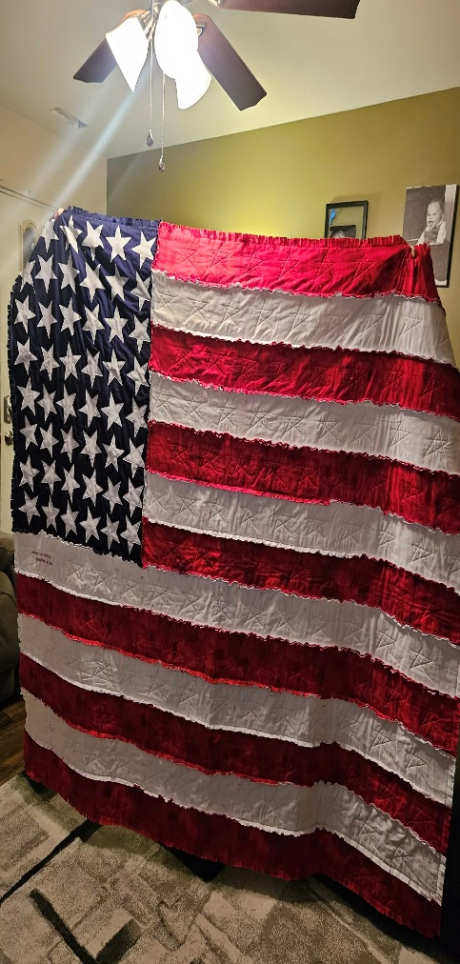
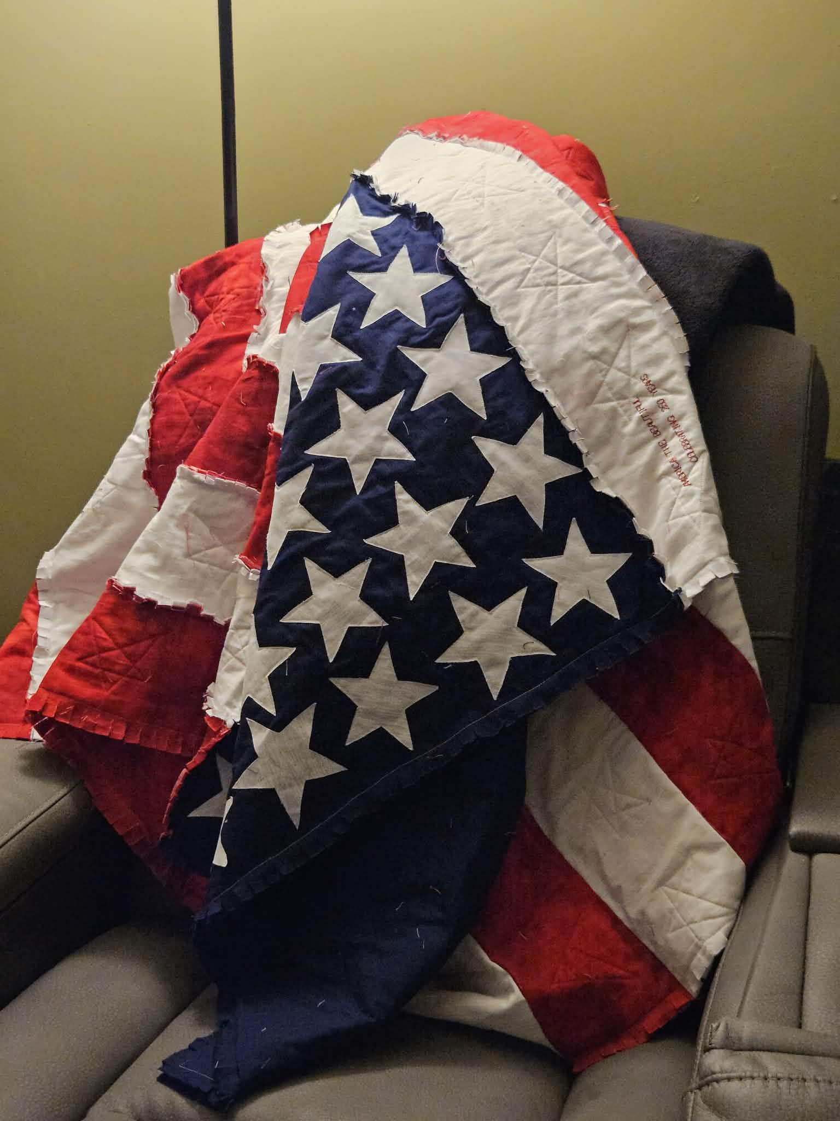
FWA BLUE STAR MOTHERS are celebrating 18 years of mission driven military support in Greater Fort Wayne and surrounding counties on Saturday August 8th, 2026
The Veterans National Memorial Shrine 2122 O’Day Road Fort Wayne IN 46818
All are welcome – light lunch/refreshments – Donations Welcome to Museum
Tickets may be purchased from any member or by contacting Barbara Eager,
president.in8 @bluestarmothers.us Cash, Venmo or PayPal

